Key Ontario HVAC Code Considerations for Supermarkets and Residential Buildings
Relevant Ontario Building Code Requirements
Ontario Building Code Part 6
Part 6 of the OBC outlines requirements for HVAC systems in buildings, including (Ontario, 2024). Ventilation standards emphasize for fresh air intake, airflow rates, and exhaust, ensuring air quality in enclosed public spaces like supermarkets and in multi-unit residential buildings. Filtration standards emphasize that filters must meet MERV ratings as prescribed for various settings (supermarkets typically require higher MERV ratings for air quality).Energy efficiency emphasize that economizer and heat recovery ventilators (HRVs) are often recommended or required for energy efficiency and are included where applicable.
Supplementary Ontario-Specific Standards
ASHRAE 62.1 and ASHRAE 90.1 are referenced in Ontario's HVAC guidelines which inform that where ventilation and efficiency requirements follow ASHRAE with slight modifications specific to Ontario’s climate. Economizers, where applicable, must operate to Ontario’s climate conditions for optimal seasonal energy savings (ASHRAE, n.d.)
Ontario Mechanical Licensing and Standards (TSSA):
It informs that compliance with TSSA guidelines is mandatory for certain mechanical equipment installations in Ontario, ensuring the safety and efficiency of HVAC equipment installations, including inspections and regular maintenance protocols.
Updated Process Flow Diagrams (PFDs) with Ontario Code Standards
Part 1: Supermarket HVAC System with Ontario Standards
Diagram Components and Symbols (with Ontario Code Compliance)
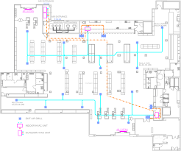
Supply Air Unit (SAU)
The main air-handling unit must be compliant with OBC Part 6 for public areas. Location & Ventilation Requirements, These aspects are place near the fresh air intake, ideally with MERV 13 or higher filters to meet Ontario’s standards for air quality in public spaces. Economizer, Ontario code suggests using economizers to reduce energy consumption by up to 30% during moderate outside temperature days. Thus the buildings follow these requirements (Canada Green Building Council, n.d.)
Return Air Ducts
As per the OBC, ducts are adequately sized and insulated to Ontario's insulation standards (OBC Part 6). Ductwork and return airflow are proportionate to ensure balanced air circulation across all zones in the supermarket.
Exhaust System
Ontario code requires specific exhaust systems for areas with food storage, waste disposal, or chemicals. Code-based locations are placed in areas like produce and storage sections to remove contaminants directly, minimizing recirculation of unconditioned air.
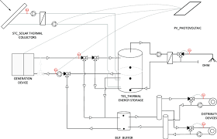
Filtration
MERV-rated filters compliant with Ontario requirements are used, especially high-rated filters near fresh air intakes and return ducts. Before and after the economizer to ensure air quality from both fresh and recirculated air. Airflow control by Ontario's HVAC balancing standards is maintained. It is ensure that fan coils meet energy efficiency ratings as outlined in ASHRAE 90.1.
Airflow Process (Ontario Compliance)
Fresh Air Intake and Economizer Operation
Fresh air is drawn in through an intake that operates the economizer to Ontario climate recommendations, conditioning air while reducing energy load (Energy.Gov, n.d.).
Supply and Return Airflow
Conditioned air is distributed to each supermarket section per the OBC for zonal temperature requirements. Return ducts direct airflow from each zone back to the SAU, passing through MERV 13 filters before exhaust or reconditioning.
Exhaust and Energy Recovery
Exhaust systems remove unconditioned or contaminated air from high-traffic areas to comply with Ontario standards. HRVs (where applicable) are used to recover heat energy in colder months, ensuring energy efficiency (Building Green, n.d.)
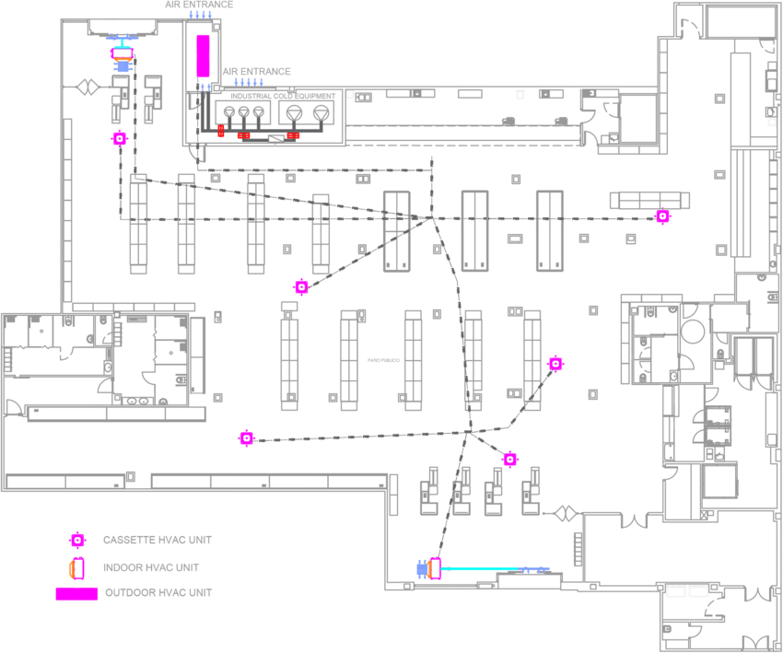
Part 2: Residential Building HVAC System with Ontario Standards
Diagram Components and Symbols (with Ontario Code Compliance)
Centralized HVAC Units
It is designed to Ontario standards for residential airflow rates (OBC Part 6) and energy efficiency. Energy Recovery Ventilators (ERVs) are installed in multi-unit residential buildings to enhance indoor air quality with minimal energy use.
Ductwork
Duct insulation meet Ontario standards for high-efficiency multi-unit dwellings. Airflow distribution per OBC Part 6 for proper ventilation to each apartment or room is maintained. Fresh Air Intakes: ERVs bring fresh air from the outside, reducing the need for standalone economizers in residential buildings.
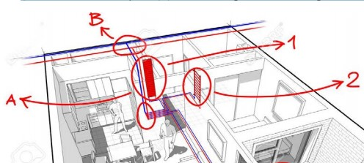
It is ensured that ERVs meet Ontario’s code requirements to meet compliance requirements for continuous ventilation in residential buildings
Filters are MERV 8 or higher, to comply with OBC Part 6 air quality standards located in each HVAC unit . To remove particulates from recirculated air and outside, filters are positioned within each unit’s HVAC or ERV. To manage indoor air quality, with direct exhaust for areas like kitchen or bathrooms, Ontario code mandates return air in each apartment. Rooftop or specified exhaust vents are connected to return ducts to comply with the legislation (Ontario, 2024)
Airflow Process (Ontario Compliance)
Fresh Air Intake and ERV Operation
To ensure controlled ventilation throughout the building, fresh air is brought in through ERVs for energy-efficient ventilation per Ontario standards
Air Supply and Distribution
Individualized temperature is maintained to minimize energy consumption based on Ontario’s climate guidelines and distributed per unit
Return and Exhaust:
Designated exhaust systems operate continuously in relation to OBC Part 6 to return air ducts collect air from each apartment to to the HVAC units
Compliance and Summary
In Ontario, both HVAC systems for supermarkets and residential buildings comply with stringent OBC and ASHRAE standards. Following is a summary of differences in relation to Ontario compliance:
Feature | Supermarket (Ontario Compliance) | Residential Building (Ontario Compliance)
Filtration | MERV 13 filters near fresh air intakes; economizer with filters | MERV 8 in each HVAC/ERV unit
Economizer and ERVs | Economizer for energy savings and ventilation control | ERVs for energy-efficient ventilation in multi-unit buildings
Exhaust Requirements | Specific to high-traffic areas, complies with OBC Part 6 | Dedicated exhaust for bathrooms/kitchens, complies with OBC Part 6
Ventilation Rates | Adjusted for Ontario’s building types under ASHRAE 62.1 standards | Individualized per apartment/room, adjustable

Following this guide, ensure that each HVAC system is depicted accurately, incorporating Ontario’s building code standards, especially parts related to energy efficiency, air quality, and system efficiency.
Supermarket Calculations
Let's take an example of the supermarket with the following specifications. The height is 10,000 sq ft, the load it has been bearing is 60,000 BTU/hr (from people and equipment) and the latent load is 15,000

Q (total load) = 60,000 + 15,000 = 75,000 BTU/hr
Airflow (CFM)= Volume × ACH/60
If we use ACH =8 and for a 12 ft ceiling height the volume of the supermarket will be 10,000×12 = 120,000 cu. ft
Putting the values in the formula:
Airflow (CFM)= 120,000×8/60 = 16,000 CFM
Now,
Duct Cross Sectional Area = CFM/Duct Velocity (fpm)
Taking the standard value of Duct Velocity = 1000
So,
Duct Cross Sectional Area = 16,000/1,000 = 16 Sq ft.
Residential Building Calculations
Residential Cooling Load (Q)
Q is equal to Qsensible and Qlatent
Heating load = U×A×T
Where,
U = 0.35 W/m2. K
A = 150 m2
T = 30 degrees
So, putting the values,
Heating load = 0.35× 150× 30 = 1,575 W

Airflow Requirement
According to Ontario code, for residential building, ACH is 0.35 and 15 CFM per person,
So, V = 1500×9 = 13,500 cu ft (9 ft ceiling case)
Airflow = 13,500 ×0.35/60 = 78.75 CFM

Thus, the energy recovery ventilator for 70% of exhaust heat would be 1575× 0.7 = 1,102.5 W

Summary Table of Key Calculation Results
Parameter | Supermarket | Residential Building
Cooling Load (BTU/hr) | 75,000 | 12,000
Heating Load (W) | 5,400 | 1,575
Required Airflow (CFM) | 16,000 | 78.75
Duct Size | 48 in × 48 in | 10 in × 8 in (for each unit)
ERV Recovery | N/A | 70%
Economizer Inclusion | Yes, for free cooling | Not typically used
These calculations will serve as a guideline to help create the process flow diagrams and to size HVAC components accurately.

References
ASHARE. (n.d.). Standards 62.1 & 62.2. https://www.ashrae.org/technical-resources/bookstore/standards-62-1-62-2
ASHARE. (n.d.). Standards and Guidelines. https://www.ashrae.org/technical-resources/standards-and-guidelines
Building Green. (n.d.). Ventilation Rates for Residential Buildings. https://www.buildinggreen.com/primer/ventilation-airflow-standards-residential-buildings
Canada Green Building Council (CaGBC) (n.d.). https://www.cagbc.org/
Energy.Gov. (n.d.). https://www.energy.gov/energysaver/weatherize/ventilation/ventilation-strategies/energy-recovery-ventilators
Government of Canada (2016). Energy Efficiency. https://natural-resources.canada.ca/energy-efficiency/10832
Heating, Refrigeration, and Air Conditioning Institute of Canada (HRAI) (n.d.). Industry. https://www.hrai.ca/
Ontario. (2024). Ministry of Energy and Electrification. https://www.ontario.ca/page/ministry-energy-and-electrification
Ontario. (2024). Ontario’s Building Code. https://www.ontario.ca/page/ontarios-building-code

